Restoring Lowland Peatland for Biodiversity & Carbon:
Lessons from the Meres and Mosses
Harper Adams University
Wednesday 20th July 2022
To register, book shuttle buses and B&B (19th July only, chargeable) at Harper Adams University please complete the following Microsoft Form If you have any queries contact Julia Casperd (+44 (0)1952 820280 Ext. 5282).

Tuesday 19th July 2022
Pre-conference site visit to Whixall Moss.
Natural England, Manor House NNR Base, Moss Lane, Whixall, Shropshire, SY13 2PD.

You are invited to attend a guided tour of the stunning Marches Mosses at Whixall Moss with Robert Duff (Project Manager www.themeresandmosses.co.uk). This SSSI is an internationally important site within the Marches Mosses and an outstanding example of nature recovery in action. The tour will provide an overview of the mosses’ fascinating history, restoration practices (e.g. bunding and sphagnum moss planting) and key biodiversity indicators, e.g. curlew, adder and white-faced darters.

Please meet at Manor House car park for 10.00 am. bring a packed lunch, drinks, wellies and waterproof clothing. Please note that access to the site is limited. Shuttle buses will depart from Harper Adams University Reception at 9.15 am and return for 4.30 pm. These must be pre-booked when registering for the conference.

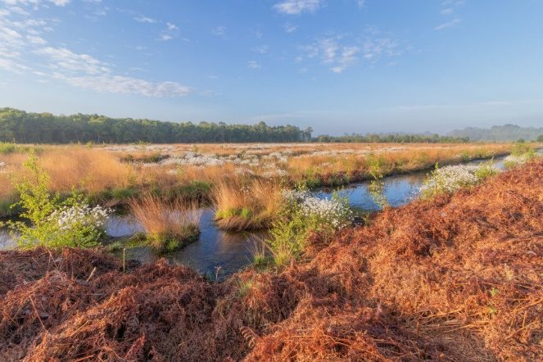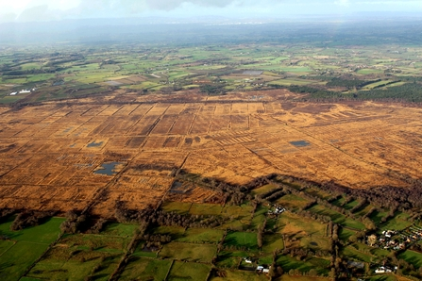

This conference has been supported by LIFE Programme of the European Union and
The National Lottery Heritage Fund.

Wednesday 20th July 2022
Restoring Lowland Peatland for Biodiversity & Carbon: Lessons from the Meres and Mosses
RFA Lecture Theatre, Harper Adams University, Shrewsbury Road, Newport, TF10 8NB.

8.30 - 9.00 am Tea & Coffee with networking/posters

9.00 am Welcome & Introduction (Julia Casperd) & Introduction to the Restoring the Marches Mosses BogLIFE Project (Robert Duff)

9.30 am Dr Renee Kerkvliet-Hermans, IUCN
‘The Peatland Code’

10.00 am Scott Kirby, Harper Adams University
‘Barriers to Regenerative Agriculture’

10.30 am Dr Brown and Kate Mayne, North Shropshire Farmers Group
‘Peatland restoration opportunities and challenges – the landowners’ perspective’

11.00 -11.30 am Tea & coffee with networking/posters

11.30 am Professor Fred Worrall, University of Durham
‘Carbon modelling at Whixall Moss’

12.00 pm Dr Chris Field, Manchester Metropolitan University
‘The Carbon Farm’

12.30 pm Robert Duff, Marches Mosses BogLIFE Project.
‘Peatland restoration for nature and ecosystem services’

1.00 - 1.45 pm Lunch – a buffet lunch will be provided

Workshops (1.45 – 3.00pm)
Delegates will be split into two groups and will alternate between workshops.

Workshop A: Best Practice for Carbon Storage and Sequestration (Simon Jeffery).
Workshop B: Best practice for Nature and Ecosystem Services (Julia Casperd).

2.45 - 3.00 pm Tea & coffee with networking/posters

4.00 pm Summary and conclusions (Julia Casperd, Simon Jeffery & Robert Duff)

5.00 - 6.00 pm Optional post-conference tour of Harper Adams University Farm led by Julia Casperd to demonstrate the different options (re-wetting & diversification) available to farmers in lowland peatland management.

Please note this program may be subject to change.

