Marches Mosses BogLIFE Project LIFE15/NAT/UK/000786

Invitation to Tender: Viewing Tower - Design and Build

Overview of Shropshire Wildlife Trust (the contracting organisation)

Shropshire Wildlife Trust is a charity established in 1962 to conserve and protect Shropshire’s wildlife. This is achieved by directly conserving wildlife and habitat, undertaking research and reconnecting people with wildlife.

Shropshire Wildlife Trust is a registered charity number 212744 and a company registered in England and Wales, number 729746. Registered Address 193 Abbey Foregate, Shrewsbury, SY2 6AH www.shropshirewildlifetrust.org.uk

Project Background

The Marches Mosses BogLIFE project is a five year project running from 1 October 2016 to 31 December 2021. The project aims to restore Britain’s 3rd largest lowland raised bog within the Fenn’s, Whixall & Bettisfield Mosses and Wem Moss NNRs near Whitchurch, Shropshire and Wrexham in Wales. The LIFE project is led by Natural England working in partnership with Natural Resources Wales and Shropshire Wildlife Trust. The multi-million pound project is supported by an EU LIFE grant and The National Lottery Heritage Fund.

More information can be found at www.themeresandmosses.co.uk

The partnership will restore lowland raised peatbog and fen lagg habitat but also improve the intellectual and physical access to the mosses. In addition to a bird hide and improving the welcome for visitors we aim to install a roofed interpretation space.

Specification

We are offering a design and build contract for the roofed interpretation space – this will take the form of a Viewing Tower. We don’t have planning permission yet so we are proposing a two phase contract;

- Phase 1 to agree the design; prepare drawings for the planning application and deal with any requests for further information.
- Phase 2 – pending successful planning outcome – construction of the viewing tower.

This will include:

- Reviewing the technical feasibility
- Ground investigations (if required) to determine structural requirements
- Preparation of concept drawings for the project team to agree final design
- Preparation of design drawings for planning application
- Assisting the project team with any technical enquiries or requests for further information during the planning application / review / consultation process
- Mobilising contractors to build the tower
- Constructing associated access boardwalk
- Being responsible for any H&S / CDM regulations.

Materials and Final structure

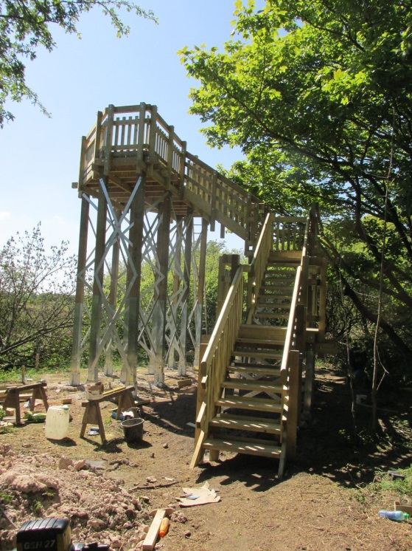
We would expect the materials to be sympathetic to the area. Ideally the tower will be maintenance free and vandal proof.

A large consideration will be avoiding damage to the SAC and Ramsar site.

As a guide we anticipate the final structure to be no higher than 5 metres.

This is an example of the kind of structure we are anticipating.

Glasson Moss

Location

Our preferred location is on the edge of Whixall Moss NNR, within the SAC and Ramsar designation and adjacent to the canal. The all ability trail finishes here and we recommend a short section of boardwalk to enable access off the all ability trail. The peat depth in this area is approximately 4m.

A site visit for interested parties will be held on 26th November 2019 at 10.30am.
Budget
As a guide we expect this to cost in the region of £45,000.

Timescales

Date | Activity
13th November 2019 | Tender issued
26th November | Site visit for interested potential suppliers
18th December | Deadline for tender responses (5pm)
19th / 20th December | Applicants notified for interviews
7th January 2020 | Interviews
Mid January 2020 | Project inception meeting

Submission

All quotes should include the project reference - LIFE15/NAT/UK/000786 – Marches Mosses BogLIFE Project.

Shropshire Wildlife Trust exists to protect wildlife for the future; sustainability is at the heart of the Trust’s activities. However, we recognise that through our operations we can have an adverse impact on the environment. We will therefore seek to minimise any negative environmental impacts and to achieve continuous improvement in our environmental performance.

We seek tenders that are in keeping with our Environmental procurement policy. For further information please see appended Environmental Procurement Policy and appended Environmental Sustainability Policy.

Please supply a response including:
- A covering letter explaining your past experience and suitability for the contract
- Examples of previous work and references
- An overview of your methodology and approach
- Detail of the materials you will use, how you will meet the brief, what practises will support SWT’s environmental considerations and what your availability is for 2020
- What regulations or standards you work to, what training employees are given etc
- Project schedule with milestones
- Total cost for each phase of the contract (incl VAT if relevant)

Your tender response must remain open for acceptance by SWT for a period of 90 days from the Tender Response Deadline. A tender response not valid for this period may be rejected.

The successful supplier will be required to complete an approved contractors questionnaire before the contract can be let.

Quotes should be returned by email to helent@shropshirewildlifetrust.org.uk by 18th December.

Criteria

Quotes will be scored against the following criteria to achieve best value:
- Ability to deliver the works (proven track record, relevant past experience and availability) – 50%
- Cost – 45%
- Empathy of the Trust’s environmental sustainability policy and environmental procurement policy – 5%

More information is available from Helen Trotman on the email above or 01743 284297.

